**2D / 3D ARRAYS**

Lab Exercise # 3

Submitted by:**Sumalinog, Ethan Chav Isaac P.**

Submitted to:**Mr. Nasvin Del Rosario**

**Lab Exercise # 3.1 - “Temperature Recorder”**

**Challenge:**

Write a program that will store and print values, the temperature recorded for at least 3 cities for the past week.

**Solution:**

Knowing that this challenge requires the usage of 2D arrays, my approach starts with asking the user how many cities are there. I am aware that the challenge asked only at least 3 but at least in this program, you can input as much cities as you want. Cities are named ‘City’ with their corresponding number (e.g. City 1). Inputting the cities creates the ‘row’ of the matrix. Being aware that there seven days a week, this creates the ‘columns’ of the matrix. I initialized the days from Sunday to Saturday inside the *days* array. With this, we have a n x 7 matrix.

I used a *for* loop in inputting the values for each of the temperature in each day. These are placed inside the *temp* array. After storing the value, they are printed using again a *for* loop.

**Code:**

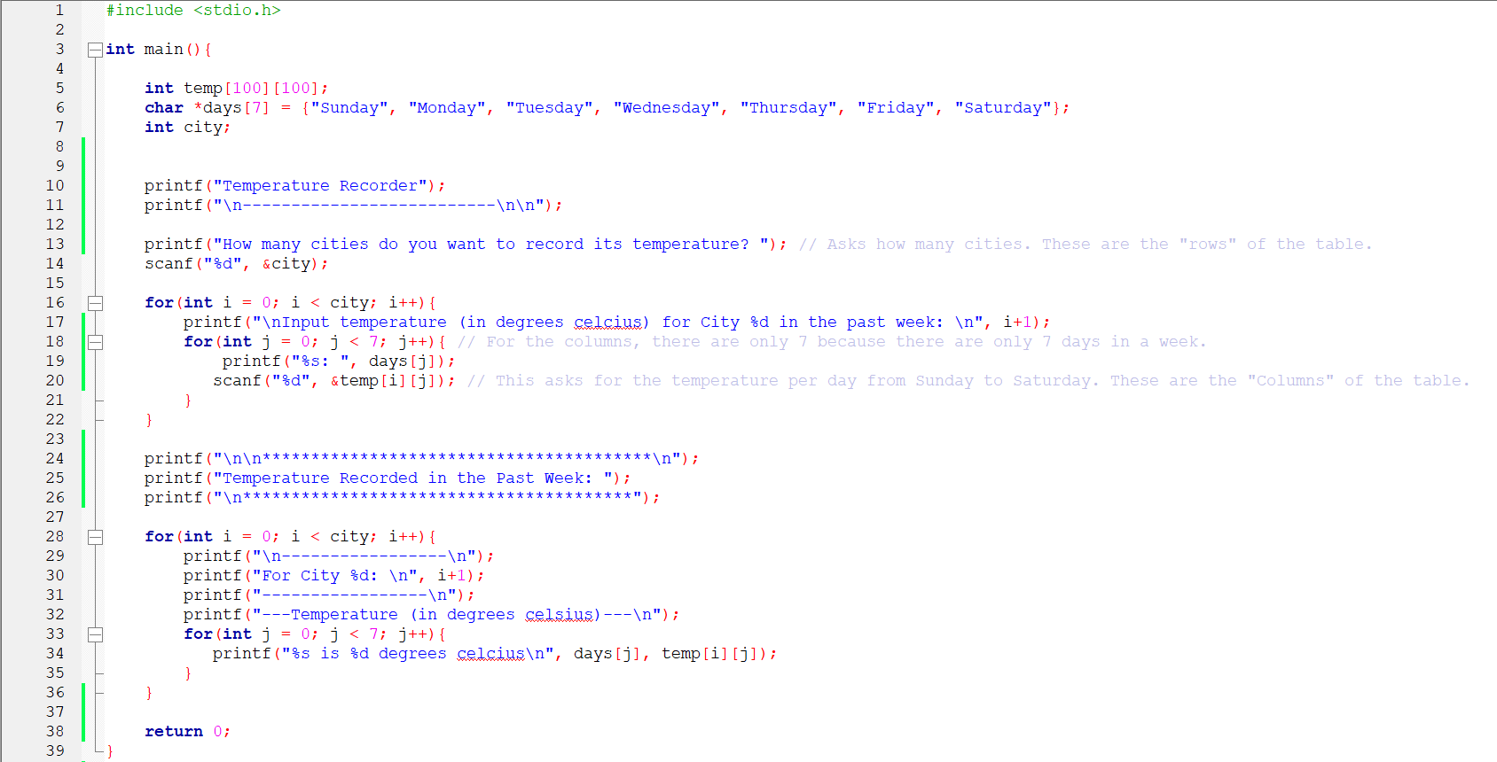

**Output:**

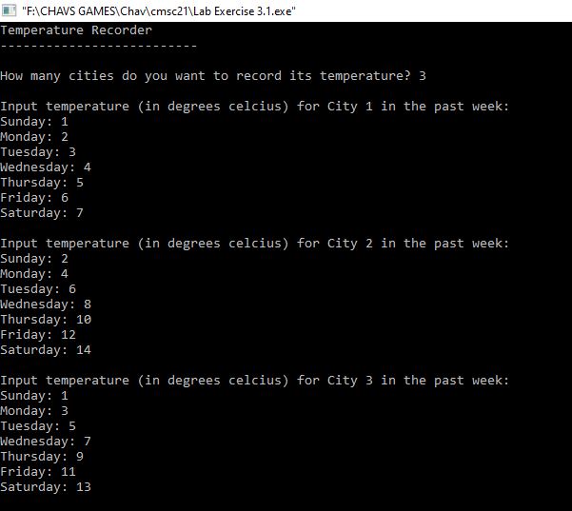

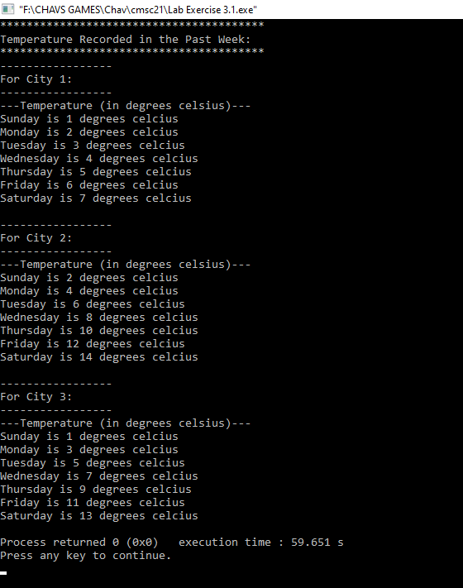

**Lab Exercise # 3.2 - “Matrix Adder”**

**Challenge:**

Write a program that will illustrate the sum of at least 3 matrices.

**Solution:**

In this matrix adder program, I first initialized 4 matrices namely, *matrix_1*, *matrix_2*, *matrix_3* & *sum*, then after the rows and columns. The matrix *sum* is used for putting the values after adding all three matrices. I then asked an input for the rows and columns for these matrices. *For* loop is then used to input the values in the matrices. Another *for* loop is then used to add each of the three matrices and the array *sum* is printed using again *for* loop. An added feature is that there is an solution of how the matrices are added to illustrate the sum.

**Code:**

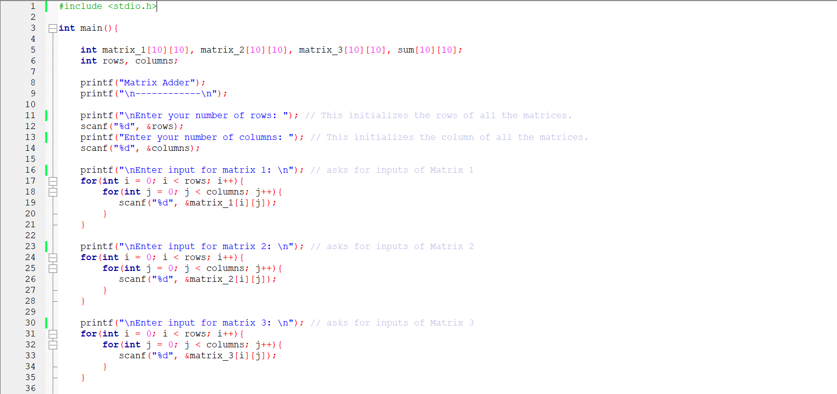

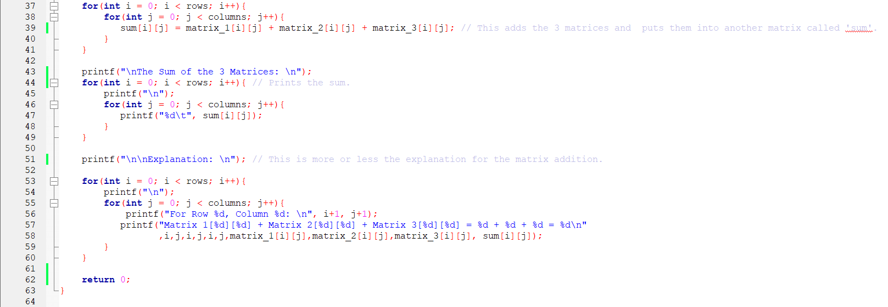

**Output:**

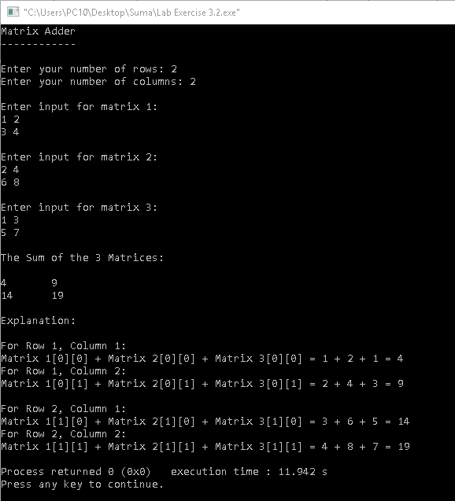

**Lab Exercise # 3.3** - **“Temperature Recorder V2.0”**

**Challenge:**

Write a program that will illustrate the use of 3D arrays.

**Solution:**

This program is the same as Lab Exercise # 3.1 that gets the temperature of the cities but with a twist. This program asks for the month and how many weeks the temperature of the cities will be inputted and outputted. With this added feature, 3D array must be used because there will be multiple 2D arrays. The number of weeks is the added layer of the array. It answers the question how many sets of 2D arrays are there. This creates a 3D array of *m* x *n* x 7, where m is the number of 2D matrices, or the number of weeks, *n* is the number of cities temperature is inputted and outputted, and lastly 7 is there because of the days of the week (Sunday to Saturday).

This program starts off the same with the temp array initialized with 3D, the days (from Sunday to Saturday), the cities, weeks and the month. The program asks for what month, then how many weeks per month and lastly how many cities. Three *for* loops are used to ask for the inputs and another three for outputting.

**Code:**

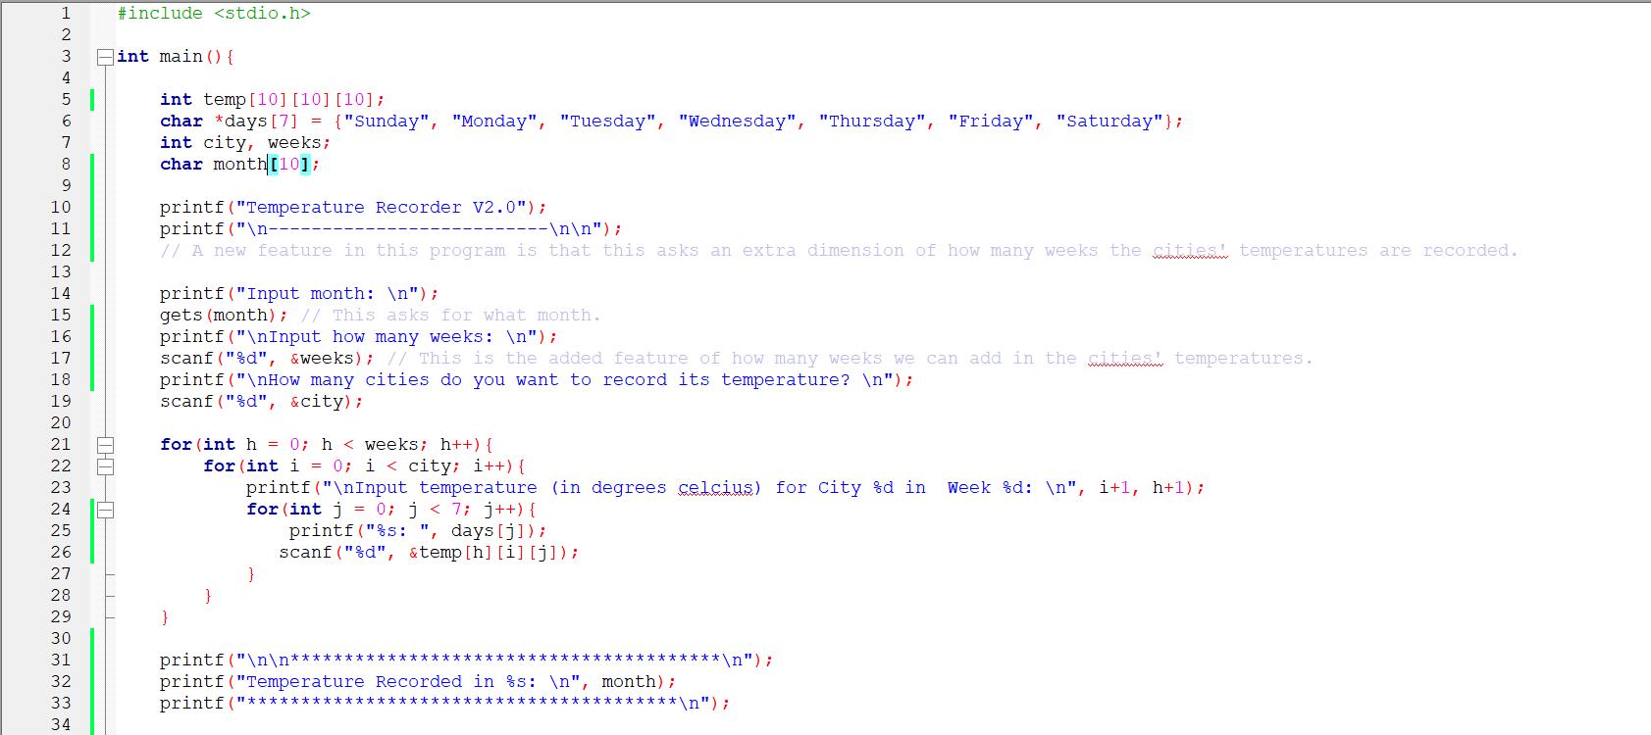

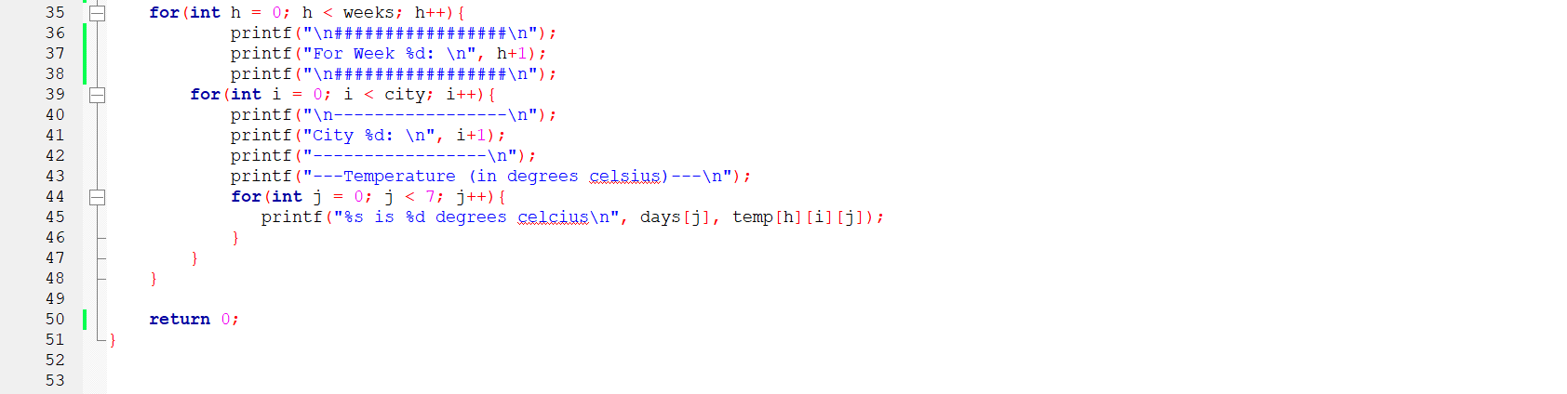

**Output:**

